

**COLLEGE OF COMPUTING AND INFORMATION SCIENCES**

**DEPARTMENT OF NETWORKS**

**BACHELOR OF SCIENCE IN SOFTWARE ENGINEERING (YEAR 2) RECESS TERM 2 (BSE 2301)**

**SOFTWARE REQUIREMENTS SPECIFICATION DOCUMENT FOR:**

**MOBILE APP STATISTICS PROJECT**

**PROJECT MEMBERS (GROUP 14)**

|  |  |  |  |
| --- | --- | --- | --- |
| **NAME** | **REGISTRATION NUMBER** | **STUDENT NUMBER** | **SIGNATURE** |
| WAMOZO COSMAS | 16/U/12299/PS | 216007584 |  |
| MUGARURA ALLAN | 16/U/7237/PS | 216008460 |  |
| BUSUULWA MARTIN | 16/U/4479/PS | 216004416 |  |
| NICHOLAS HENRY SSEBIRUMBI | 16/U/11512/EVE | 216011052 |  |

**PROJECT LEADER**

NICHOLAS HENRY SSEBIRUMBI

**SUPERVISOR**​

MBABAZI ISAAC

**24TH​ JUNE, 2018**

**Software Requirements**

**Specification**

**for**

**Mobile app Statistic**

**Version 1.0 approved**

**Prepared by Group 14**

**Makerere University**

**27th June, 2018**

### Table of Contents

Contents

Table of Contents 3

Revision History 6

1. Introduction 7

1.1 Purpose 7

1.2 Document Conventions 7

1.3 Intended Audience and Reading Suggestions 7

1.4 Product Scope 8

2. Overall Description 8

2.1 Product Perspective 8

2.2 Product Functions 8

2.3 User Classes and Characteristics 9

2.4 Operating Environment 11

2.5 Design and Implementation Constraints 12

2.5.1 Hardware Limitations 12

2.5.2 Software Limitations 12

2.5.3 Security Limitations 12

2.6 User Documentation 12

2.7 Assumptions and Dependencies 12

2.7.1 Assumptions 12

2.7.2 Dependencies 12

3. External Interface Requirements 13

3.1 User Interfaces 13

3.2 Hardware Interfaces 13

3.3 Software Interfaces 13

3.4 Communications Interfaces 13

4. System Features 13

4.1 Home 14

4.1.1 Description and Priority 14

4.1.2 Stimulus/Response Sequences 14

4.1.3 Functional Requirements 14

4.2 Import dataset 15

4.2.1 Description and Priority 15

4.2.2 Stimulus/Response Sequences 15

4.2.3 Functional Requirements 15

4.3 Visualization 16

4.3.1 Description and Priority 16

4.3.2 Stimulus/Response Sequences 16

4.3.3 Functional Requirements 16

4.4 Summary 17

4.4.1 Description and Priority 17

4.4.2 Stimulus/Response Sequences 17

4.4.3 Functional Requirements 18

4.5 Help Feature 18

4.5.1 Description and Priority 18

4.5.2 Stimulus/Response Sequences 18

4.5.3 Functional Requirements 18

5. Other Nonfunctional Requirements 20

5.1 Performance Requirements 20

5.2 Safety Requirements 20

5.3 Security Requirements 20

5.4 Software Quality Attributes 20

5.5 Business Rules 20

Appendix A: Glossary 22

References 23

Figure 1: Use case diagram for Mobile App Statistics 10

Figure 2: Home tab interface 14

Figure 3: import dataset interface 15

Figure 4: Visualization interface 16

Figure 5: Summary interface 17

Figure 6: Help interface 18

Figure 7: Sentiment analysis interface 19

## Revision History

|  |  |  |  |
| --- | --- | --- | --- |
| **Name** | **Date** | **Reason For Change** | **Version** |
| Mobile app statistics | 24th June, 2018 | No reason | 1.0 approved |
|  |  |  |  |

# 1. Introduction

## 1.1 Purpose

This Software Requirements Specification provides a complete description of all the functions and specifications of the project “Mobile app statistics”.

It describes the purpose and features of the project, interfaces, functional and non-functional requirements.

The expected audience of this document is the department of Networks of the College of Computing and Information Sciences (**COCIS**) at Makerere University as well as the developers and anyone who intends to develop on this project.

## 1.2 Document Conventions

The document is edited using the following formats; alignment justify, font size 12, font style times new roman, line spacing 1.5, font color black.

This Document was created based on the IEEE template for System Requirement Specification Documents.

## 1.3 Intended Audience and Reading Suggestions

* Developers, such as students, who want more people to download their applications can use the mobile app statistic program to analyze their app details to find out how they affect their ratings on the App store using the system features.
* Programmers who are interested in working on the project by further developing it or fix existing bugs must use this document to refer on the design and implementations constraints of the project.
* Marketing staff, will use this document to explain the non-functional requirements such as performance, security, safety, quality attributes and business rules to the clients and funders.
* Document writers may refer to this document to document other data analytical based projects.
* Project manager, will use this document track progress and also to evaluate the project basing on the scope.

## 1.4 Product Scope

The **Mobile App Statistics** is data system that analyzes app details from the **App Store** and generates insights which are intended to help developers get more people to download their applications and optimistically increase the user ratings of their apps. Users of this system can use it to collect analysis on how different application details affect the user ratings of an application on the store and also app details can be visualized giving a clear understanding of the data to the users.

# 2. Overall Description

## 2.1 Product Perspective

Mobile App Statistic system being developed is a new self-contained software product. It is a data analysis system that uses datasets from the apple store containing apps with their app details and app groups and generates statistics and insights on how those details affect user ratings. The system is developed for every app developer who is interested using this analysis to structure his application with the aim of acquiring more user ratings. It is also useful to anyone interested in analyzing data from the Apple store in order to produce various visualization of that data.

The system is an open source software product with a graphical user interface.

## 2.2 Product Functions

The system shall use mathematical techniques such as linear regression to show correlation between different app details and user ratings.

Data visualization: The system will visualize data such as bar plots, scatter plots, box plots and many others that will be used to generate insights below;

* Showing how the price of an app affect the user rating and which app groups are most bought which will help app developers while pricing their apps.
* Differentiating between app versions showing whether new versions have improved the app ratings.
* Showing which app group has the best, average, and least user ratings which will give app developers a field to focus on most.
* Showing how the size of an app affect its user rating.
* Showing how app screen shots shown when users are downloading apps affect user rating.
* Showing how languages supported by the App affect user ratings.

Sentimental analysis:

* The system will perform this analysis on the app descriptions to generate total sentiment scores of the motions in the descriptions.
* From the generated motions the system will generated polarity of the motions to show if the app descriptions are either more positive or more negative.

## 2.3 User Classes and Characteristics

There are numerous user classes for this product. They include the following:

* Developers, such as students, will use the visualization to determine which App group is preferred most and measures to be taken to get more downloads.
* Programmers who are interested in working on the project by further developing it or fix existing bugs.
* Marketing staff, they are responsible for advertising the software product so they will mostly use the visualizations to determine the general views of App developers and how best they can improve them.
* Management, will use the product to determine which App group has the most ratings such that App developers can focus on developing applications in such categories.

**Use Case diagram for the system**



Figure 1: Use case diagram for Mobile App Statistics

|  |  |  |
| --- | --- | --- |
| **Name** | **Description** | **Function** |
| User | Person who interacts with the system | Interacts with the system |
| Import dataset | This feature enables users to import a dataset compatible with the system | Enables a user to import a dataset |
| visualize | Represents the data in a graphical format | Creates graphs and other graphical components used for collecting analysis |
| Display graphs and summary | This feature displays graphs and summaries | Displays graphs and summaries |
| Create Summary | Contains a detailed summary of the dataset | Contains a summary of mathematical functions (mean, quartile, max, min) applied on the dataset |
| Perform sentimental analysis | Contains sentimental scores based on motions of the app description and the polarity of the description | Creates graphs of motions and polarity |
| Get Help | Contains guidelines on how the user should interact with the system | Guides the user on how to interact with the system |

## 2.4 Operating Environment

The software product will be running on Windows 10 but it will be able to run on any other operating system that supports R.

## 2.5 Design and Implementation Constraints

The system is developed using R, R studio, and R packages like **shiny** which will be used to design interfaces that will help in displaying visualization and other data analysis conclusions.

### 2.5.1 Hardware Limitations

The software product will be developed to run on computers with 2GB RAM memory as a minimum requirement. hence it may not be fast enough to run the complex software functions.

The system will run on a computer with 32-bit or 64-bit processor.

### 2.5.2 Software Limitations

The R version used may not be able to run on any computer since each version of R requires specific versions of the operating systems on the computers on which it is installed.

### 2.5.3 Security Limitations

The product will not have any passwords and so the data used and processed might be accessed by anyone who can interact with the system.

## 2.6 User Documentation

The system will have an online help option which will be in form of a small documentation to guide the users on some aspects that may be hard for them to understand.

## 2.7 Assumptions and Dependencies

### 2.7.1 Assumptions

The users of the system must have R installed on their computers.

Since the system is using complex R packages, it must be run on the version of R 1.6 and higher.

The app Store dataset which is going to be used in this project is authentic.

### 2.7.2 Dependencies

The Mobile App statistic system will not reuse any software from other projects hence being d

# 3. External Interface Requirements

## 3.1 User Interfaces

The user interface will be designed to be displayed in a browser hence users should have a browser installed on the computer.

It will be designed using an R package called Shiny.

The interface contains a dashboard with the; Home tab that gives a simple description of the system, Visualization tab that gives you different graphical options for the uploaded data, Summary tab that gives you the summaries of the analysis. The main panel to display the graphs and text, and the help tab to show how the user can navigate the system.

## 3.2 Hardware Interfaces

The system will need to run on a computer with at least 32MB RAM and 500 MHz CPU.

The system will not be supported on mobile devices.

## 3.3 Software Interfaces

The system will be implemented using R version 3.5 or higher and R studio software. The Shiny package will be used in R studio to develop user interfaces and many other packages.

The system will be developed on both windows 10 and Ubuntu 16.04.2 LTS operating systems. There will be no need for a database since we shall be importing datasets for analysis.

## 3.4 Communications Interfaces

Users will have to import the CSV file datasets for analysis using the FTP. There is no need for internet connection.

# 4. System Features

This section shows the system’s most prominent features and explains how they can be used and their outputs to the users.

## 4.1 Home

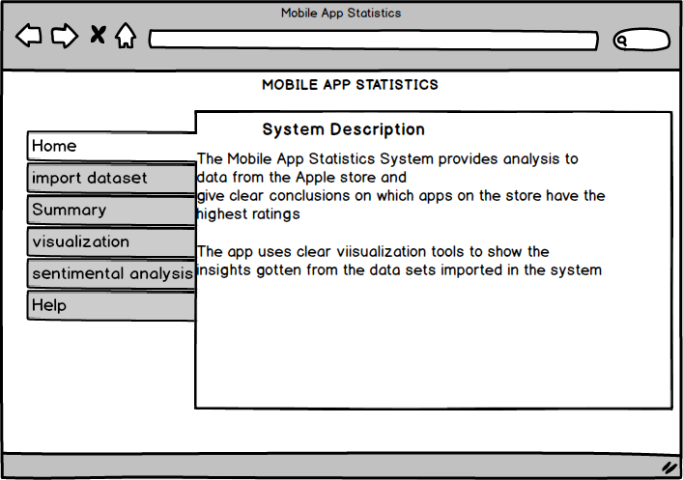

Figure 2: Home tab interface

### 4.1.1 Description and Priority

This feature will give a simple description of the system to the user when the system is opened. This is a moderate priority feature as it’s not too important to the user.

### 4.1.2 Stimulus/Response Sequences

The user opens the Mobile App Statistics system.

The user clicks on the Home tab.

The system displays the system description.

### 4.1.3 Functional Requirements

**REQ-1:** The system will display the system description.

## 4.2 Import dataset

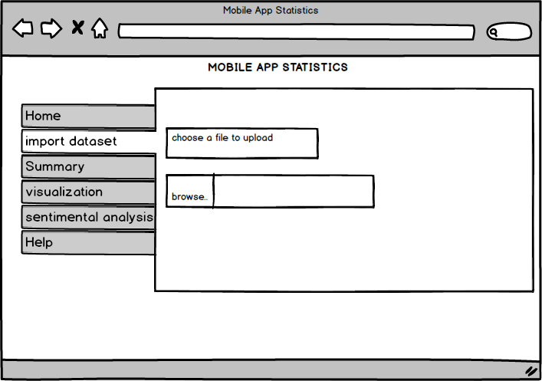

Figure 3: import dataset interface

### 4.2.1 Description and Priority

This feature will allow users to import datasets in CSV file format compatible with the system for analysis. This feature has the highest priority since all functions need datasets to work effectively.

### 4.2.2 Stimulus/Response Sequences

The user opens the Mobile App Statistics system.

The user clicks on the Upload CSV file button.

The system opens a file explore window.

The user selects the file from the file system.

The user clicks on Open button to upload the file.

### 4.2.3 Functional Requirements

**REQ-2:** The system should allow users to upload CSV file datasets for analysis.

## 4.3 Visualization

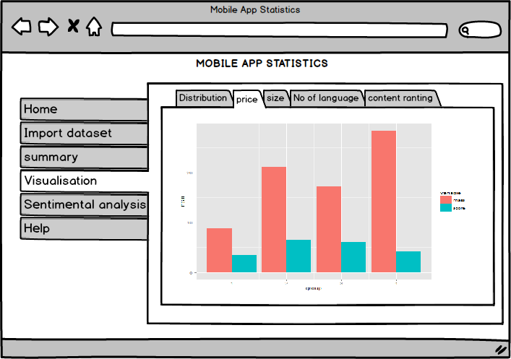

Figure 4: Visualization interface

### 4.3.1 Description and Priority

This feature is the part of the system for plotting graphs such as bar plot, mosaic maps, heat maps, histograms, box plots and many others that will help show the insights from the data. This feature also has a high priority of all features in the system.

### 4.3.2 Stimulus/Response Sequences

The user opens the Mobile App Statistics system.

The user clicks on the visualization tab.

Then selects on the different visualization techniques displayed by clicking on them.

The selected graph is displayed.

### 4.3.3 Functional Requirements

**REQ-3:** The system will show how the price of an app affect the user rating.

**REQ-4:** The system will differentiate between app versions showing whether new versions have improved the app ratings.

**REQ-5:** It will also show which app group has the best, average, and least user ratings.

**REQ-6:** The system will also show how the size of an app affect its user rating.

**REQ-7:** It will show how app screen shots shown when users are downloading app affects user rating.

**REQ-8:** The system will show how languages supported by the App affect user ratings.

**REQ-9:** The system will not visualize anything if the dataset is not uploaded.

## 4.4 Summary

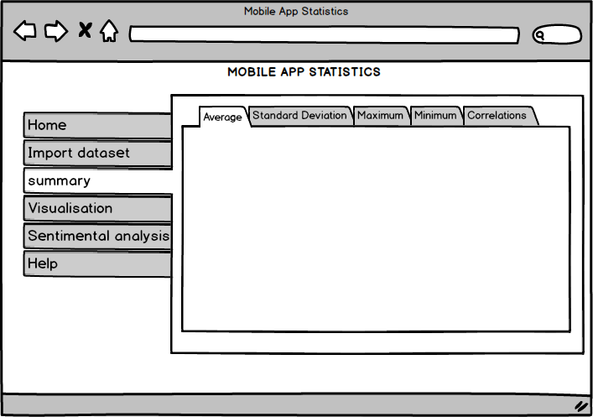

Figure 5: Summary interface

### 4.4.1 Description and Priority

This feature will give an analysis on the datasets by performing different data science techniques on the dataset provided. This is also a high priority feature.

### 4.4.2 Stimulus/Response Sequences

The user opens the Mobile App Statistics system.

The user clicks on the Summary tab.

The system displays the summary options.

The user selects from among the options.

The system displays the summaries depending on the option selected.

### 4.4.3 Functional Requirements

**REQ-10:** The system will display summaries from the analysis on the dataset provided.

**REQ-11:** The system will not generate summaries if the dataset is not uploaded.

## 4.5 Help Feature

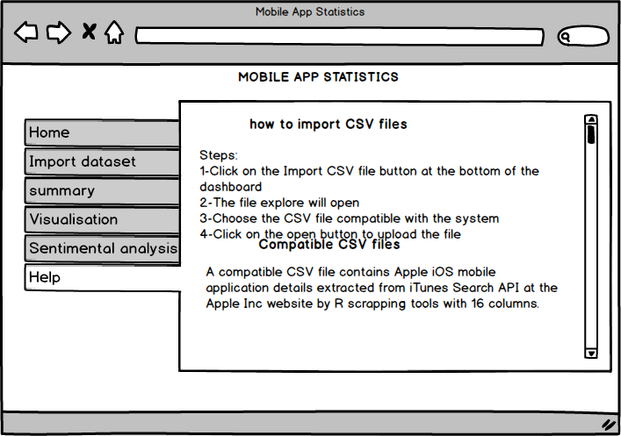

Figure 6: Help interface

### 4.5.1 Description and Priority

The feature will give help and controls of how the system works and how the user can effectively utilize it. The feature has a moderate priority compared to other features.

### 4.5.2 Stimulus/Response Sequences

The user opens the Mobile App Statistics system.

The user clicks on the Help tab.

The system displays the help options for the user.

### 4.5.3 Functional Requirements

**REQ-12**: The system will display the help options and controls to the users regardless whether the dataset is uploaded or not.

## 4.6 Sentimental Analysis

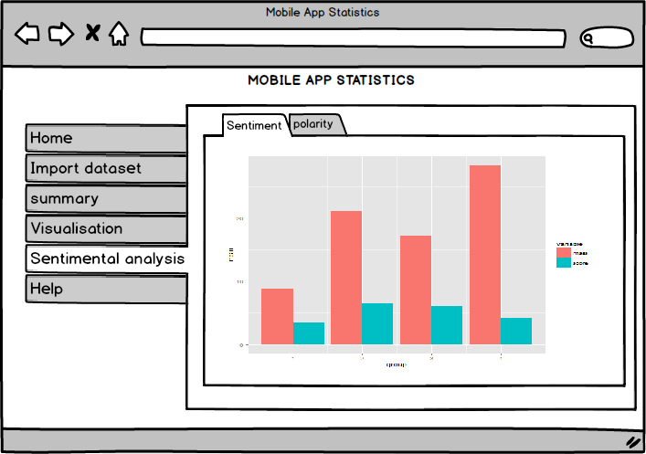

Figure 7: Sentiment analysis interface

### 4.6.1 Description and Priority

This feature is part of the system which will enable the user to view the polarity and the sentiment motion score of the app descriptions

### 4.6.2 Stimulus/Response Sequences

The user opens the Mobile App Statistics system.

The user clicks on the sentimental analysis tab.

The system displays a screen with two tab.

The user selects on either sentiment or polarity.

The system displays the results depending on the selected tab.

### 4.6.3 Functional Requirements

**REQ-13:** The system should be able to calculate eight types of emotions for example Anger, Joy, Disgust, Anticipation, Sadness, Surprise, Fear and Trust present within the uploaded data file.

**REQ-14:** The system should be able to deduce the polarity of a given review i.e. if a review is Negative or Positive.

# 5. Other Nonfunctional Requirements

## 5.1 Performance Requirements

The system will need to run on a computer with at least 32MB RAM, 500 MHz CPU and enough hard disk free space at least 1GB for recovered files, image files, etc.

For the system to work effectively, the dataset will have to be a CSV file format.

## 5.2 Safety Requirements

Since the system will be developed to take less system resources, it will not halt the operating system while its processing hence supporting multitasking without loss of any data. The help tab will be useful to the user by giving them steps for the effective use of the system.

## 5.3 Security Requirements

The system will not need any user authentication mechanisms therefore the system can be used by any user as long as he or she uses a compatible CSV file.

## 5.4 Software Quality Attributes

The system will be developed for every user hence ensuring its availability.

The system will provide both simple and advanced visualization techniques to favor all kinds of users.

The system will be compatible with any operating system except for mobile operating systems.

The system will be documented to ensure good software testing and quality control management.

## 5.5 Business Rules

* Advanced or professional users such as software engineers, computer scientists, researchers, data scientists who want to use the system for more demanding analysis of the app details on the App store.
* Programmers who are interested in working on the project by further developing it or fixing bugs.
* Developers, such as students, who want to use this system to get more people to download their applications can use the mobile app statistic program to analyze their app details to find out how they affect their ratings on the App store using the system features.

# Appendix A: Glossary

1. Graph: a system of nodes connected in pairs by edges. Often subdivided into [directed graphs](https://en.wikipedia.org/wiki/Directed_graph) or [undirected graphs](https://en.wikipedia.org/wiki/Undirected_graph) according to whether the edges have an orientation or not. [Mixed graphs](https://en.wikipedia.org/wiki/Mixed_graph) include both types of edges.
2. Data visualization: it involves the study and creation of the visual representation of data e.g. points, lines or bars contained in graphics. The goal is to communicate information clearly and efficiently to users.
3. Data analysis: it is the process of inspecting, transforming, cleansing and modeling data with a goal of discovering useful information, informing conclusion and supporting decision.
4. CSV file: it stands for “comma-separated values”, it is a simple file format used to store tabular data, such as a spreadsheet or database. Files in the csv format can be imported to and exported from programs that store data in tables, such as Microsoft Excel or OpenOffice Calc.
5. R studio: it allows a user to run R in a more user-friendly environment, it is open-source (i.e. free)
6. Bug: an error, failure or fault in a program that causes it to produce an incorrect or unexpected result or behave.
7. Sentimental analysis: Here we classify the polarity of given text at the document, sentence, or feature/aspect level-whether the expressed opinion in a document, sentence or an entity feature/aspect is positive, negative or neutral.

## References

[1] Apple Store Optimization (ASO):

<https://www.apptamin.com/blog/app-store-optimization-app-ratings/>

[2] Wikipedia

https://en.m.wikipedia.org>wiki